June 2024

**MARVEL and Swarovski SS24: Fantastic Figurines Crafted With Epic Style**

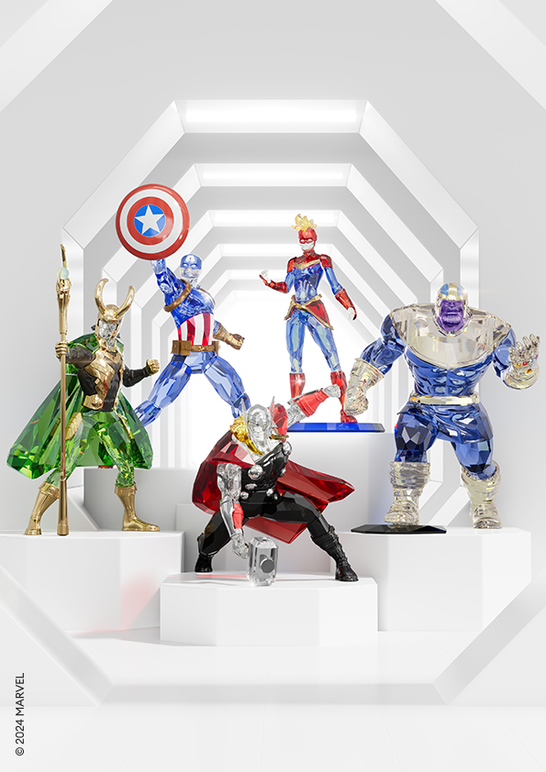

MARVEL and Swarovski join forces once again, building on a shared dedication to celebrating the wonder in fantasy and self-expression.

Bringing fans worldwide a vivid reimagining of their most beloved comic book icons, MARVEL x Swarovski returns with a dazzling new home collection designed to command attention and energise interiors.

Expertly crafted using full-cut facets in bright and bold hues, each crystallised character gleams powerfully, channelling a mix of courage, intelligence, and strength.

A thrilling testament to Swarovski savoir-faire and MARVEL power, the Spring/Summer 2024 collection embraces the power of crystals to celebrate Super Heroes and epic villains with dynamic radiance.

Featuring Captain America, Thor, Thanos, Loki, and Captain Marvel as solo figurines, as well as a stunning composite MARVEL Avengers piece, the collection’s precision finishes display a remarkable attention to detail. Intensely vibrant colours highlight Swarovski’s prismatic brilliance, while instantly recognisable elements and classic poses are inspired by MARVEL’S epic heroes.

**MARVEL X SWAROVSKI HOME COLLECTION**

CAPTAIN AMERICA

A shining example of loyalty, might, and resilience, Captain America is reimagined with 382 dazzling facets. From his familiar features to his indestructible shield, Swarovski honours the ultimate Super Hero with outstanding technical mastery.

THOR

In a combative pose, the God of Thunder is one of MARVEL’s most recognisable characters. Swarovski’s mighty crystallised Thor figurine features 523 facets and mixed metal finishes. Every detail has been expertly cut, including Thor’s devastating hammer, Mjolnir, resulting in an extraordinary shine.

THANOS

A powerful tribute to MARVEL’S villainous titan, this imposing figurine is crafted from 607 crystallised facets with polished metal details. Wearing a protective suit of armour as well as his legendary infinity stones, Thanos radiates supreme strength.

LOKI

There is no mistaking Loki with his luminous green hue and horned helmet. Gold tone lacquered metal and 282 facets combine in a striking collectible that perfectly represents Swarovski’s unparalleled crystal artistry.

CAPTAIN MARVEL

Prepped for action in her signature red and blue suit, this radiant figurine captures Captain Marvel’s formidable character with extraordinary precision. 427 facets and high-shine metal bring the vivid design to life.

AVENGERS SHOWPIECE

For the very first time, Swarovski has assembled a full team of Super Heroes in one astonishing display. Meticulously rendered in Swarovski’s unique Pointiage® technique, this strictly limited-edition masterpiece depicts Black Widow, Hulk, Iron Man, Captain America, and Black Panther in battle-ready mode. Combining more than 70,000 handset crystals in an explosion of green, red, black, and blue, the dramatic Avengers scene is one of the most breathtaking examples of Swarovski savoir-faire ever produced. A must-have for MARVEL and crystal fans, only 200 Avengers showpieces are available globally.

The MARVEL x Swarovski home collection is available online and in Swarovski stores.

[Assets here.](https://swarovski-my.sharepoint.com/:f:/p/u5187178/EkY2oFbVyVBDitss-2DkbPcB4jP3tM4xlaNDyv3DOOYBjg?e=Cjx82b)

**For more information, please contact:**

SwarovskiGlobal PR: [global.pr@swarovski.com](mailto:global.pr@swarovski.com) 

**ABOUT SWAROVSKI**

Masters of Light Since 1895

Swarovski creates beautiful products of impeccable quality and craftsmanship that bring joy and celebrate individuality.

Founded in 1895 in Austria, the company designs, manufactures, and sells the world's finest crystals, Swarovski Created Diamonds and zirconia, jewellery, and accessories, as well as home décor. Swarovski Crystal Business has a global reach with approximately 6,600 points of sale, of which 2,300 are owned stores, in over 150 countries and employs 16,600 people. Together with its sister companies Swarovski Optik (optical devices) and Tyrolit (abrasives), Swarovski Crystal Business forms the Swarovski Group. A responsible relationship with people and the planet is part of Swarovski’s heritage. Today this legacy is rooted in sustainability measures across the value chain, with an emphasis on circular innovation, championing diversity, inclusion, and self-expression, and in the philanthropic work of the Swarovski Foundation, which supports charitable organisations bringing positive environmental and social impact.